Lab 08
a) Write a method that computes the sum of the digits in an integer. Use the following method header: public static int sumDigits(long n). For example, sumDigits(234) returns 9 (2 + 3 + 4). b) Write a method with the following header to display an integer in reverse order: public static void reverse(int number) For example, reverse(3456) displays 6543. Write a test program that prompts the user to enter an integer and displays its reversal.
Solution
import java.util.Scanner;

public class LabTask1 {

// a) Sum of digits
public static int sumDigits(long n) {
int sum = 0;
while (n != 0) {
sum += n % 10;
n /= 10;
}
return sum;
}
// b) Reverse an integer
public static void reverse(int number) {
int reversed = 0;
while (number != 0) {
reversed = reversed * 10 + number % 10;
number /= 10;
}
System.out.println("Reversed number: " + reversed);
}

public static void main(String[] args) {
Scanner sc = new Scanner(System.in);

System.out.print("Enter an integer: ");
int num = sc.nextInt();

// Task a
System.out.println("Sum of digits: " + sumDigits(num));

// Task b
reverse(num);
}
}
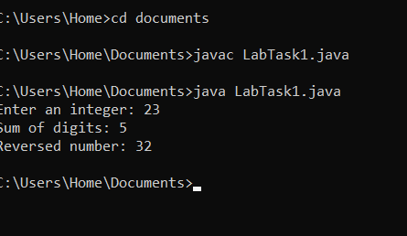
Lab Task 2
Write the methods with the following headers // Return the reversal of an integer, i.e., reverse(456) returns 654 public static int reverse(int number) // Return true if number is a palindrome public static boolean isPalindrome(int number) Use the reverse method to implement isPalindrome. A number is a palindrome if its reversal is the same as itself. Write a test program that prompts the user to enter an integer and reports whether the integer is a palindrome.
Solution
import java.util.Scanner;

public class LabTask2 {

// Return reversal of a number
public static int reverse(int number) {
int reversed = 0;
while (number != 0) {
reversed = reversed * 10 + number % 10;
number /= 10;
}
return reversed;
}

// Check if palindrome
public static boolean isPalindrome(int number) {
return number == reverse(number);
}

public static void main(String[] args) {
Scanner sc = new Scanner(System.in);

System.out.print("Enter an integer: ");
int num = sc.nextInt();

if (isPalindrome(num)) {
System.out.println(num + " is a palindrome.");
} else {
System.out.println(num + " is not a palindrome.");
}
}
}
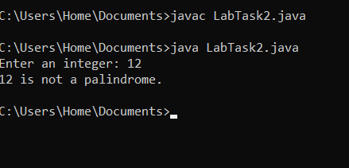

Lab Task 3
Write a method with the following header to display three numbers in increasing order: public static void displaySortedNumbers(double num1, double num2, double num3) Write a test program that prompts the user to enter three numbers and invokes the method to display them in increasing order.
Solution
import java.util.Scanner;

public class LabTask3 {

public static void displaySortedNumbers(double num1, double num2, double num3) {
double temp;
if (num1 > num2) { temp = num1; num1 = num2; num2 = temp; }
if (num1 > num3) { temp = num1; num1 = num3; num3 = temp; }
if (num2 > num3) { temp = num2; num2 = num3; num3 = temp; }

System.out.println("Numbers in increasing order: " + num1 + " " + num2 + " " + num3);
}

public static void main(String[] args) {
Scanner sc = new Scanner(System.in);
System.out.print("Enter three numbers: ");
double n1 = sc.nextDouble();
double n2 = sc.nextDouble();
double n3 = sc.nextDouble();

displaySortedNumbers(n1, n2, n3);
}
}
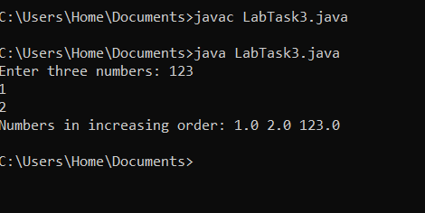
Lab Task 4
Write a method that returns the number of days in a year using the following header: public static int numberOfDaysInAYear(int year) Write a test program that displays the number of days in year from 2000 to 2020.
Solution
public class LabTask4 {

public static int numberOfDaysInAYear(int year) {
if ((year % 4 == 0 && year % 100 != 0) || (year % 400 == 0)) {
return 366; // Leap year
}
return 365; // Normal year
}

public static void main(String[] args) {
for (int year = 2000; year <= 2020; year++) {
System.out.println(year + ": " + numberOfDaysInAYear(year) + " days");
}
}
}
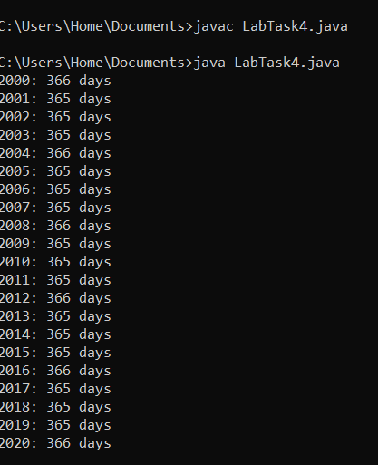
Lab Task 5
Write a method that counts the number of letters in a string using the following header: public static int countLetters(String s) Write a test program that prompts the user to enter a string and displays the number of letters in the string.
Solution
import java.util.Scanner;

public class LabTask5 {

public static int countLetters(String s) {
int count = 0;
for (int i = 0; i < s.length(); i++) {
if (Character.isLetter(s.charAt(i))) {
count++;
}
}
return count;
}

public static void main(String[] args) {
Scanner sc = new Scanner(System.in);
System.out.print("Enter a string: ");
String input = sc.nextLine();

System.out.println("Number of letters: " + countLetters(input));
}
}
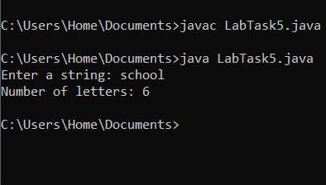
Lab Task 6
Write a function capitalize(lower_case_word) that takes the lower case word and returns the word with the first letter capitalized. Eg., System.out.println(capitalize(“word”)) should print the word Word.Then, given a line of lowercase ASCII words (text separated by a single space), print it with the first letter of each word capitalized using the your own function capitalize()
Solution
import java.util.Scanner;

public class LabTask6 {

public static String capitalize(String word) {
if (word.isEmpty()) return word;
return word.substring(0, 1).toUpperCase() + word.substring(1);
}

public static void main(String[] args) {
Scanner sc = new Scanner(System.in);
System.out.print("Enter a line of lowercase words: ");
String line = sc.nextLine();

String[] words = line.split(" ");
StringBuilder capitalizedLine = new StringBuilder();

for (String word : words) {
capitalizedLine.append(capitalize(word)).append(" ");
}

System.out.println("Capitalized line: " + capitalizedLine.toString().trim());
}
}
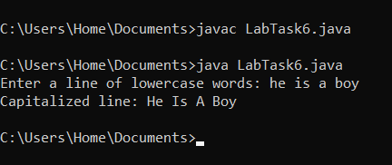
Lab task 7
Write a method that displays an n-by-n matrix using the following header: public static void printMatrix(int n) Each element is 0 or 1, which is generated randomly. Write a test program that prompts the user to enter n and displays an n-by-n matrix
Solution
import java.util.Scanner;
import java.util.Random;

public class LabTask7 {

public static void printMatrix(int n) {
Random rand = new Random();
for (int i = 0; i < n; i++) {
for (int j = 0; j < n; j++) {
System.out.print(rand.nextInt(2) + " ");
}
System.out.println();
}
}

public static void main(String[] args) {
Scanner sc = new Scanner(System.in);
System.out.print("Enter n: ");
int n = sc.nextInt();

printMatrix(n);
}
}
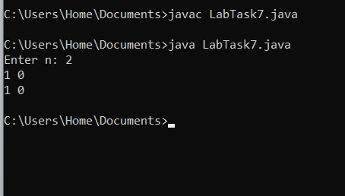

Lab Task 8
Write a Java method to count all vowels in a string.
Solution
import java.util.Scanner;

public class LabTask8 {

// Method to count vowels
public static int countVowels(String str) {
int count = 0;
str = str.toLowerCase(); // Convert to lowercase for easier checking

for (int i = 0; i < str.length(); i++) {
char ch = str.charAt(i);
if (ch == 'a' || ch == 'e' || ch == 'i' || ch == 'o' || ch == 'u') {
count++;
}
}

return count;
}

public static void main(String[] args) {
Scanner sc = new Scanner(System.in);

System.out.print("Enter a string: ");
String input = sc.nextLine();

int vowelCount = countVowels(input);
System.out.println("Number of vowels: " + vowelCount);
}
}
